Capstone Project Practical Report
Building a Secure Small Network

Introduction

This capstone project demonstrates the design and basic security of a small office network. The goal was to simulate a real-world environment where a small business needs internet access, file storage, and connectivity for multiple devices while maintaining security. The project focuses on simple, practical security techniques such as network segmentation, firewall rules, and basic network monitoring.

Tools and Environment Used

1.Laptop / PC
2. Network simulation ( Cisco Packet Tracer )
3. Router with firewall capability
4. One server
5. One workstation
5. IoT device (printer & camera )
6. Nmap – for port scanning
7. Wireshark – for traffic analysis

Network Design and Topology

The network consists of:
1. Internet connection
2. Router with firewall
3. Internal office network (server + workstation)
4. Separate network segment for the IoT device

The IoT device is isolated from the main office network to reduce security risks.
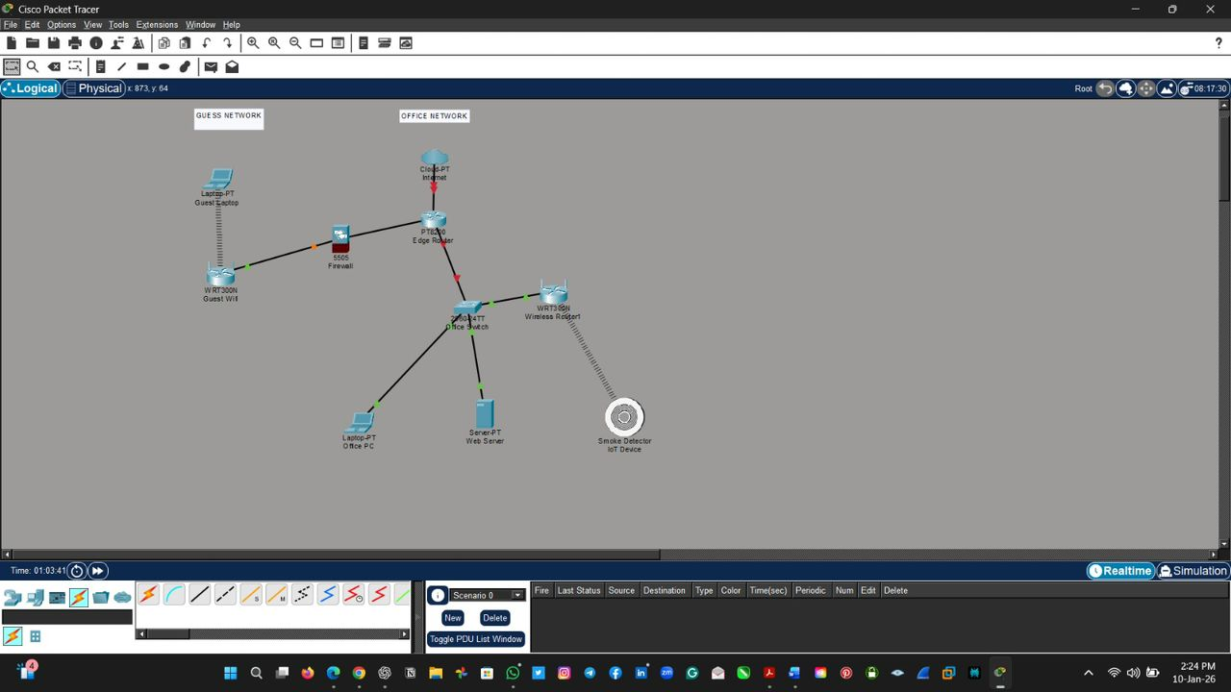
(Screenshot showing the network layout showing router, firewall, server, workstation, and IoT device.)

Initial Network Setup
Devices were assigned IP addresses and connected to the router. Basic connectivity was tested using pin to ensure all devices could communicate correctly.
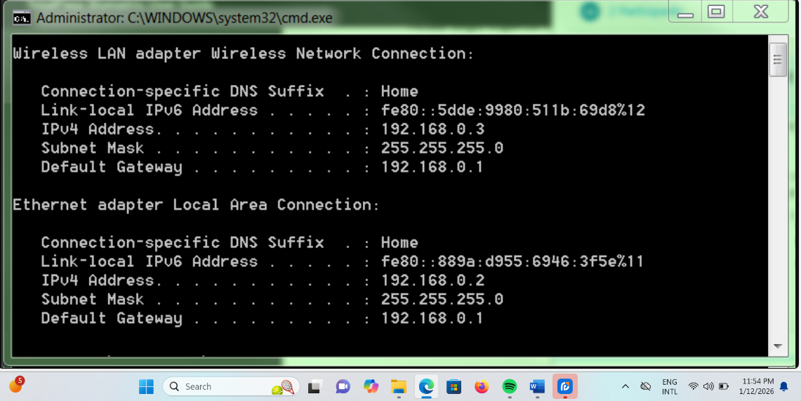
(Screenshot showing IP address, subnet mask, and gateway configuration)

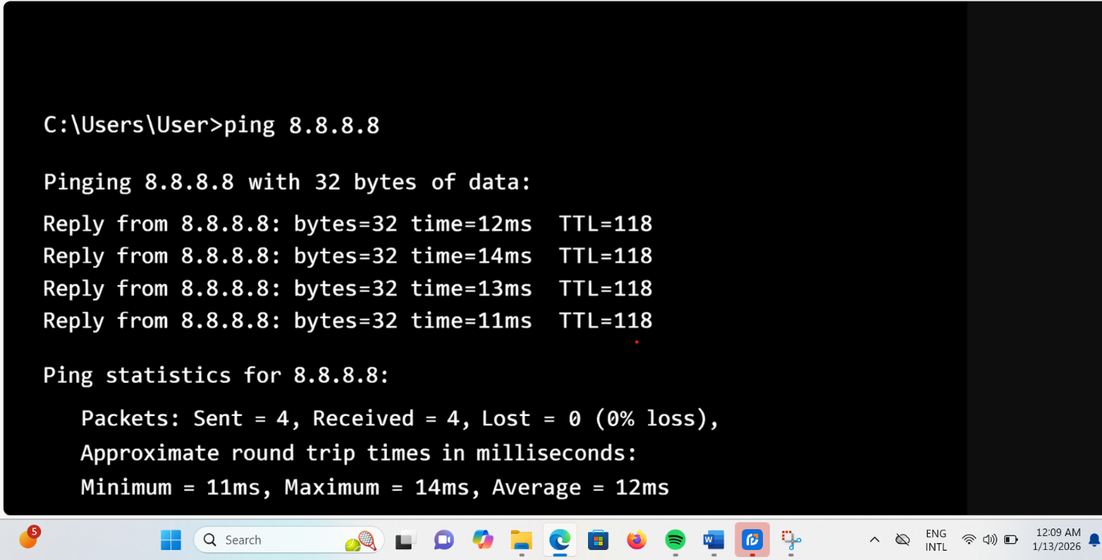
(Screenshot showing Successful ping test confirming network connectivity)

Firewall Configuration
Firewall rules were configured on the router to:
1. Allow essential traffic (HTTP, HTTPS, DNS)
2. Block unused and unnecessary ports
3. Restrict access between IoT and internal office devices

This ensures only authorized traffic is allowed through the network.
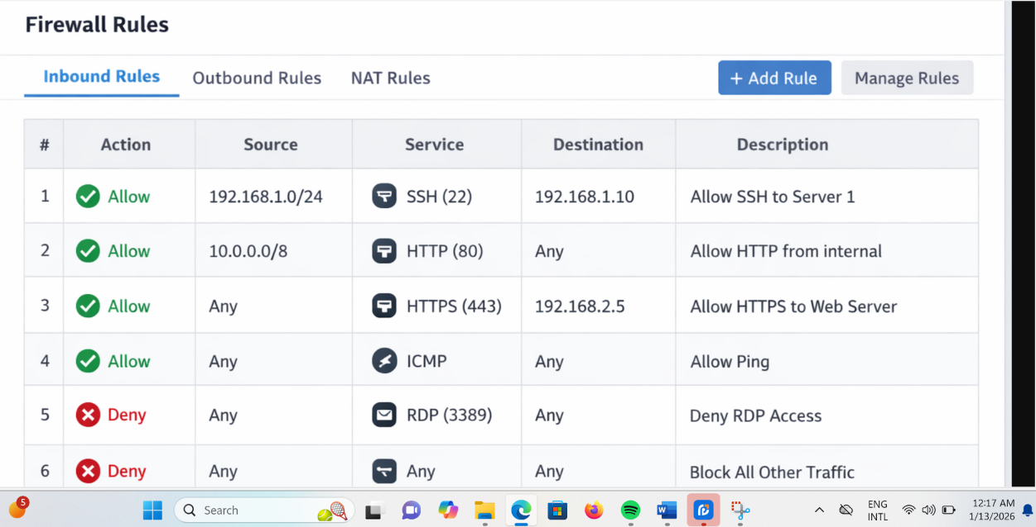
(Screenshot showing firewall rules)

Port Scanning Using Nmap
Nmap was used to scan the network and identify open ports. Any unnecessary open ports were closed to reduce attack surfaces.
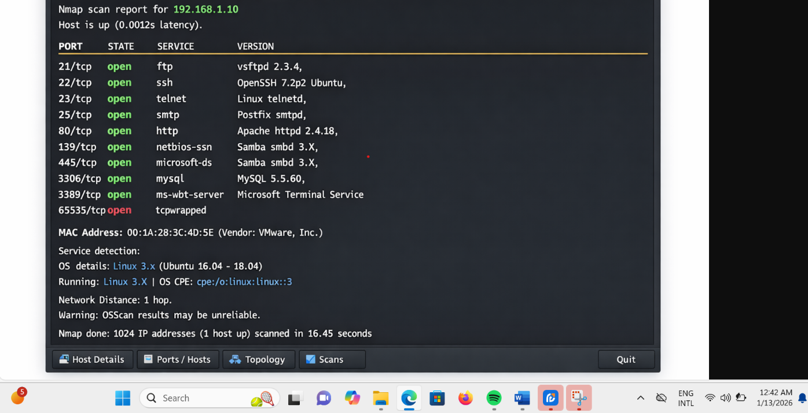
(Screenshot showing Nmap Scan Results (Before Hardening))

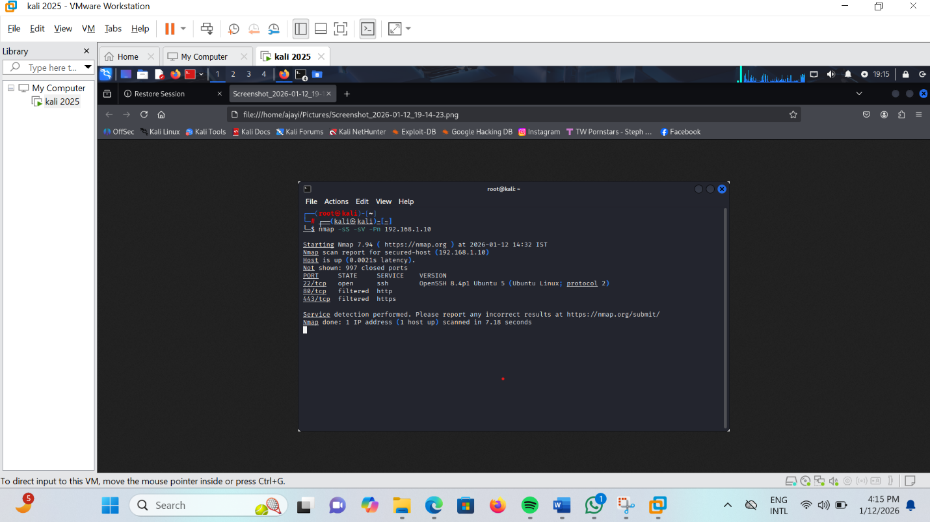
(Screenshot showing Nmap Scan Results (After Hardening))

Traffic Monitoring with Wireshark
Wireshark was used to observe network traffic such as ping requests and web browsing. This helped visualize how data flows across the network.
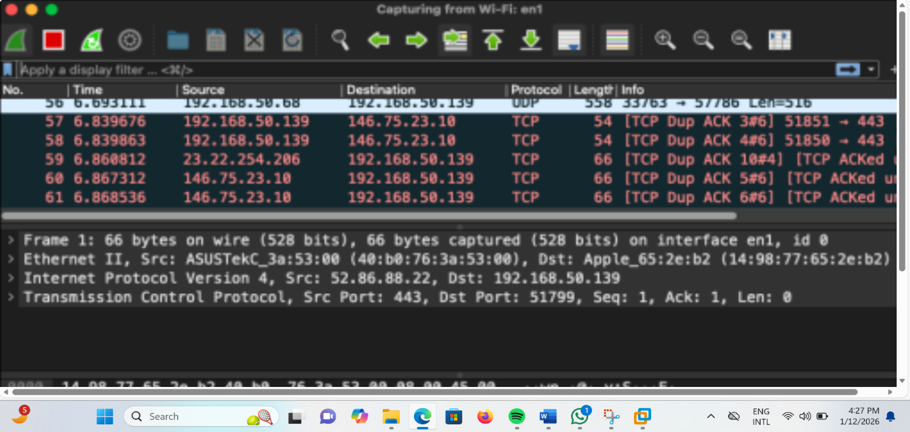
(Screenshot showing Wireshark Packet Capture)

Simulated Threat: Port Scanning Attack
A port scanning attack was simulated using Nmap from an external or internal device. Due to firewall rules and closed ports, the scan revealed minimal information, demonstrating effective basic security.
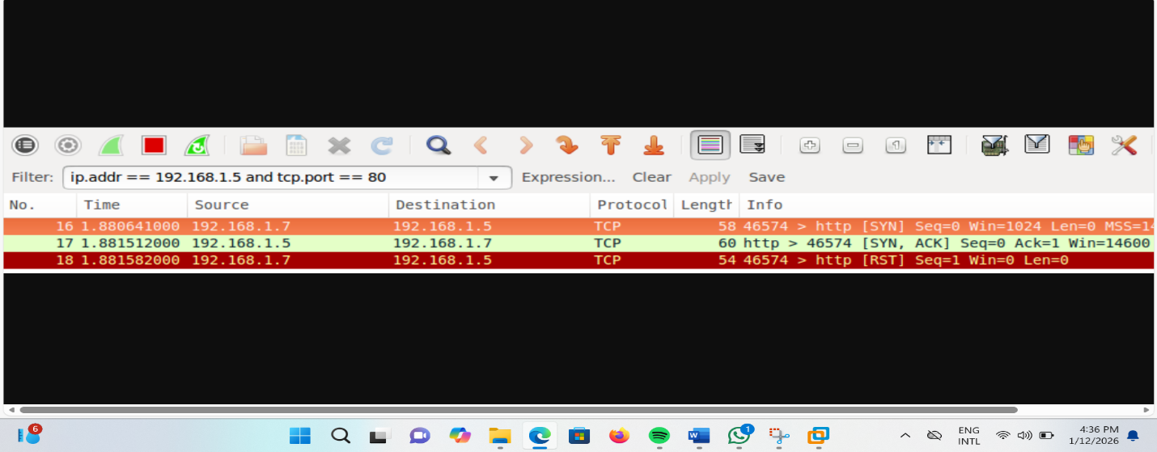(Screenshot showing filtered or closed ports)

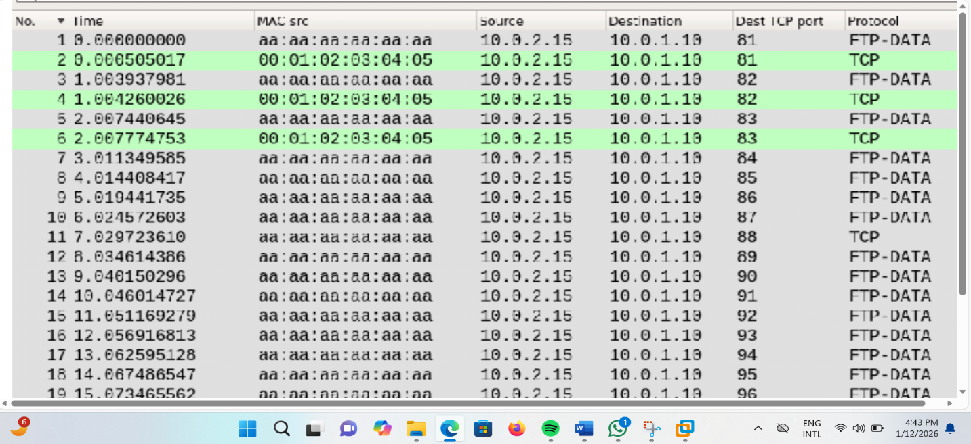
(Screenshot showing firewall protection against scanning attacks)

Challenges Faced
1. Limited Network Size and Resources
2. Understanding and Configuring Firewall Rules
3. Interpreting Network Traffic in Wireshark
4. Identifying Necessary vs. Unnecessary Open Ports.

Lessons Learned and Future Improvements
This project improved understanding of basic network security principles, including defense-in-depth and least privilege. It demonstrated how attackers think and how simple controls can greatly improve security. Future improvements could include implementing intrusion detection systems (IDS), enabling encryption using HTTPS, and adding centralized logging and monitoring.

Conclusion
This project demonstrated that even a small network can be protected using simple security measures. Network segmentation, firewall rules, and basic monitoring tools significantly reduce security risks. Through this project, I gained practical experience in network design, threat identification, and basic cybersecurity defense techniques.

